# DATABASE SYSTEM PRACTICUM REPORT

# MODULE 7

**JOIN**



**CREATED BY :**

**KURNIAWAN BAGASKARA**

**L200214253**

# INFORMATICS STUDY PROGRAM

**FACULTY OF COMMUNICATION AND INFORMATION SCIENCE MUHAMMADIYAH SURAKARTA UNIVERSITY**

1. 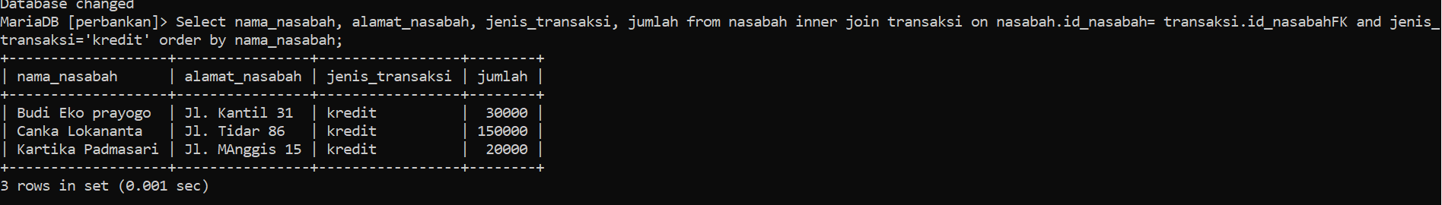
2. 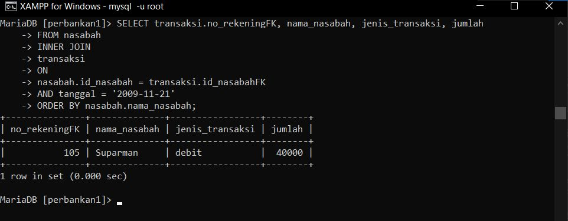
3. 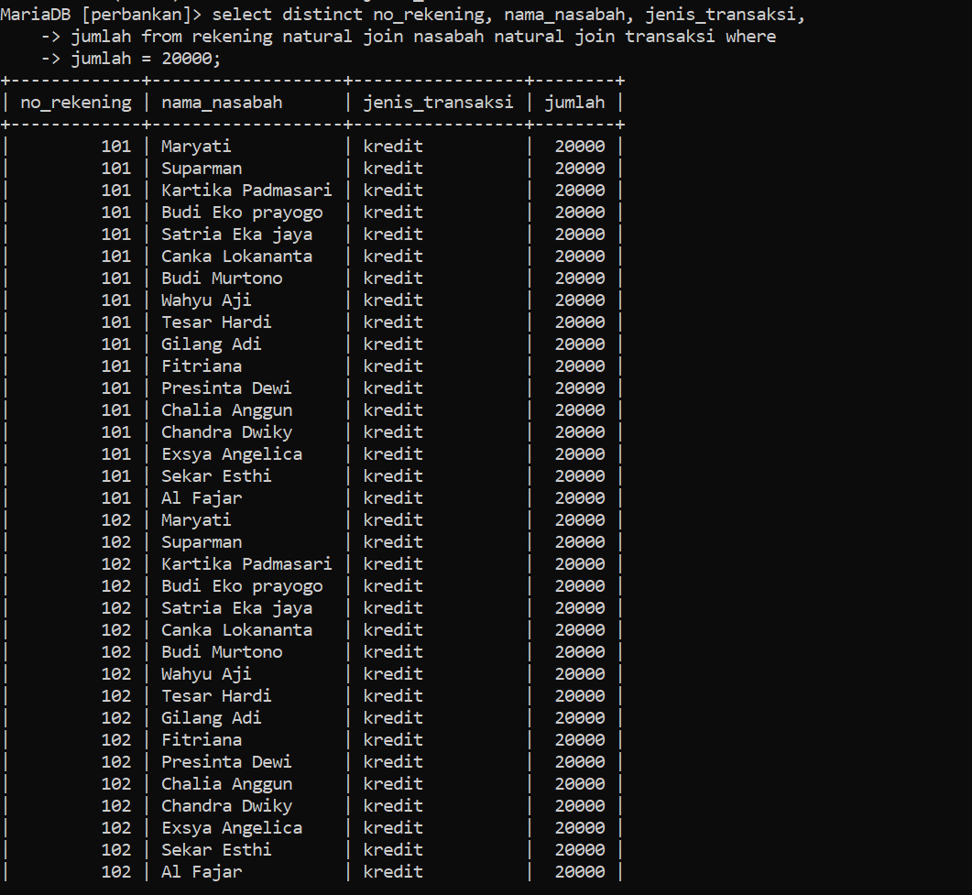
4. 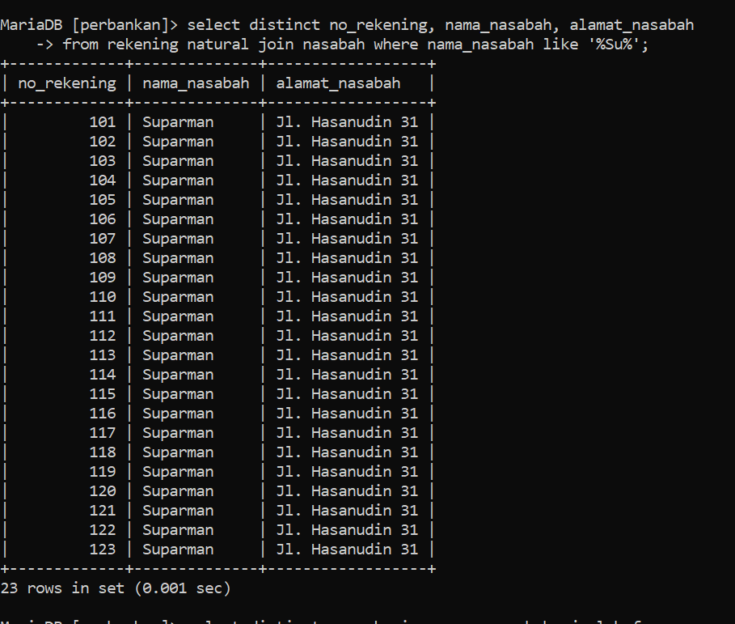
5. 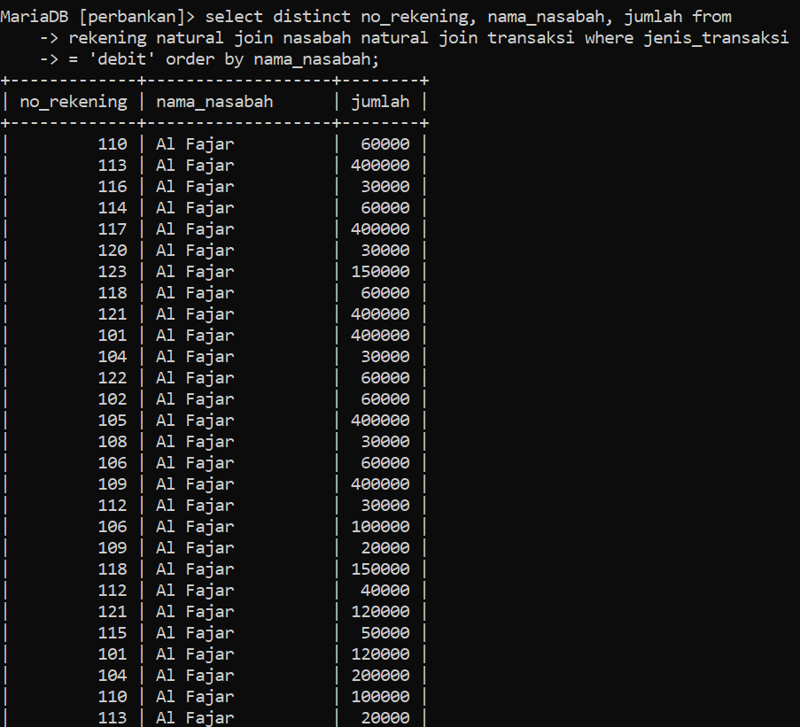
6. do 5 questions

* Combine all account and customer record tables 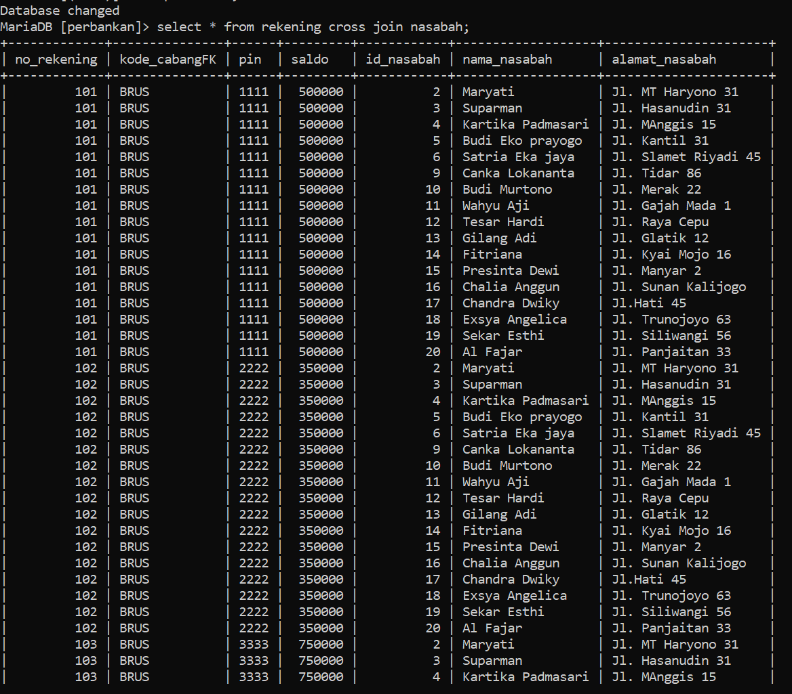
* Finding intersections between accounts and customer tables 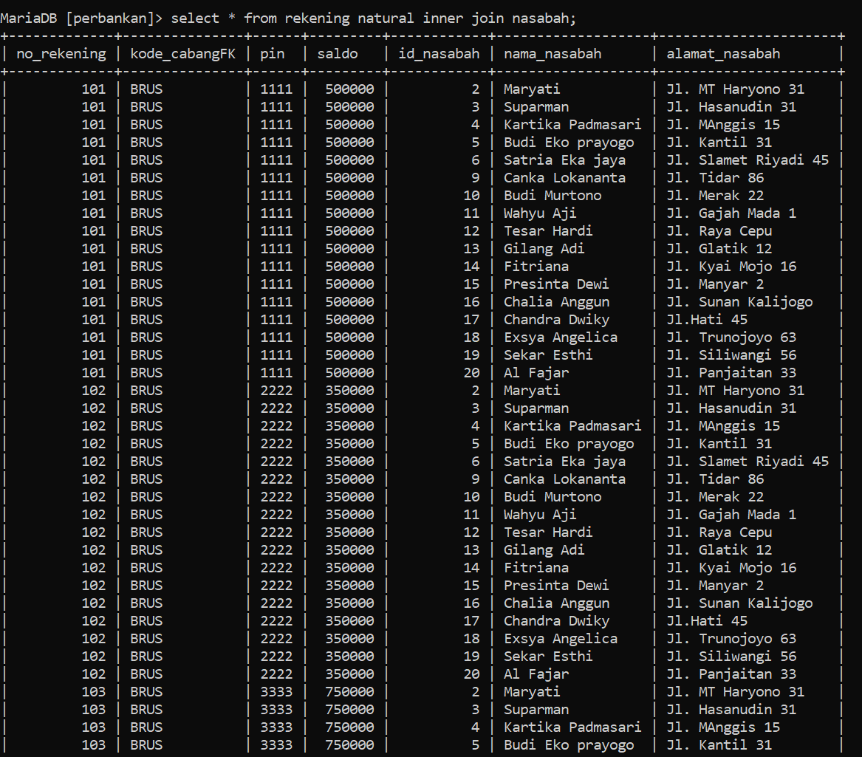
* Merge all customer and bank_branch record tables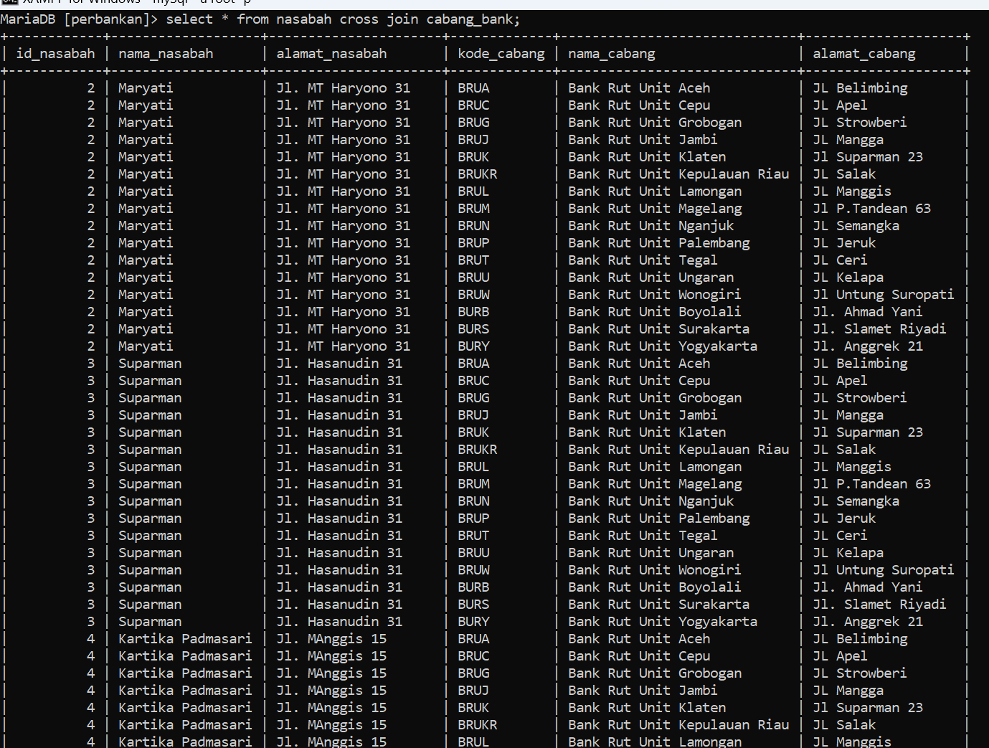
* Displays the results of the customer and branch_bank join tables along with the 2nd/right record table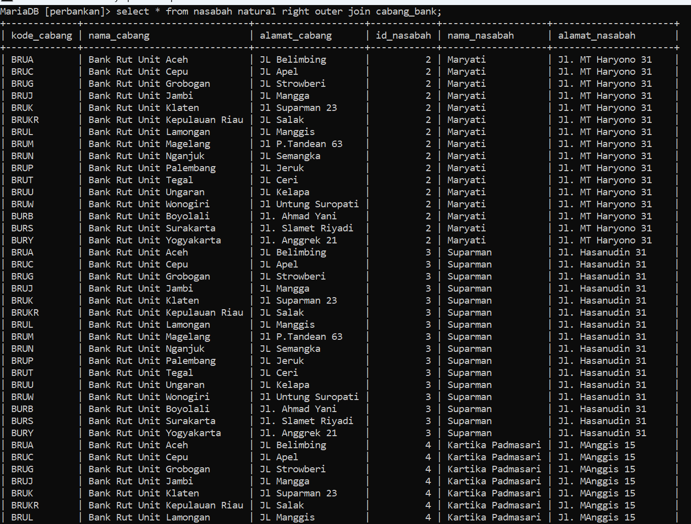
* Displays the results of the customer and branch_bank join tables along with the 1st/kir record table